Torque netting
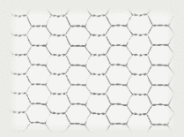 | Material-heat treated low carbon wire. Mesh size 100 can be produced from galvanized wire.  Length of roll is 50 meters or more.  Aperture is distance between opposite sides of hexahedron.

Aperture, mm | Wire diameter |  | Width, mm | Weight in kgs per 1 sq.m.
Aperture, mm | mm | inch | Width, mm | Weight in kgs per 1 sq.m.
25 | 0,6 | 0,024 | 500, 1000, 1500, 2000 | 0,252
100 | 0,6 | 0,024 | 1000, 1500, 2000, 2500, 3000 | 0,068

